# **University of Calgary**

# 

# **CPSC 481: Foundations of HCI, Fall 2017**

# **Assignment #2**

# **Asian Food Cooking Instructor**

# **Hungry Panda**

**For**

**Dr. Ehud Sharlin, Kurtis Danyluk**

**By**

**BenKun Chen**

**JiongKai Jiang**

**MuZhou Zhai**

**Phillip Renwick**

**Lysov Anton**

**Re-design Rationale**

According to the walkthrough of our low-fidelity prototype we find some problems within our design, so we modify our prototype without changing the functionalities. All changes are associated with design of interface, and we separate theses improvements into four parts.

The first improvement is related with the profile icon. The previous version of profile icon is just an image and do not have another other implementation. Right now when people click this icon, it will let people go to account page, and this page is a list of buttons which have different functionalities, and all these functionalities are only related with this user. At present, there are only two buttons, one is the comments history and the other is user’s favourite dishes. If there are some new implementations, we will add them later. The reason why we do this change is that login system must have a centralized control system, then, users can find all functionalities under account page. Obviously, it is easier for customers to find the information which has been saved on their account and also help them to delete the things if they do not like their old comments or dishes. Therefore, customers will have more motivation to use our app because it is organised and convenience.

Next, we change the home page. Originally, we assume popular page as our home page, but from the worthrough of the work context we find that some people like Jonathan A. Mackenzie will use popular page a lot. They do not know what to cook, so they randomly choose an attractive dish to cook. However, the popular page’s dishes will keep same if more and more people use our app because some dishes will be very popular and stay at the top of the popular list all the time. For this reason we change this page, so the dishes will not rank as the popularity. Instead of using popularity, we list all dishes based on the daily recommendation, and each day has different suggestions. If we do this kind of improvement, the customers will not few boring when they browse home page everyday. Moreover, the bottom button bar has been changed. The layout is popular, search and favourite in the past, but now we only have two buttons which are home and search. The reason why we have this improvement is that we put favourite dishes button into account page, and the popular button become home button. As we know, a good home page will attract more people to use our app, so a good recommendation list become very important.

Thirdly, we have added a keyword search functionality to our original searching system. In the original searching interface, there is only one searching functionality by selecting search filters. There are three search filters in the original searching interface. They are ethnicity, difficulty and food allergy. Once users make their decision selecting these filters, they can get the recipes ordered by popularity after clicking the search button. However, we recognized our searching method is too simple, and may not find what user exactly want in for some users. For example from our work through, Jonathan A. Mackenzie who is a native people with average cooking skill. Jonathan is not familiar with asian culture and asian food, so that he may not definitely sure about the recipe ethnicity. What’s more, We take the walk through for James Clark for another example, James is a cooking beginner with few knowledge for Asian food. It may be confused for him to select the difficulty for the recipe he wants. For users like Jonathan and James, the original searching interface may not offer them their expected recipes, as well as the motivation due to knowledge lacking. However, they may remember the name of the cuisine or the recipe ingredients that impressed him or her the most. So we add a keyword searching functionality, that there is a text bar allows users’ input. The keyword can be the name or the ingredients of the recipes. By using the new keyword searching functionality, users like Jonathan and James can find what they want easier.

Finally, in the ingredients page, we changed some buttons in the toolbar, as well as moved the *add to favorite* button from the top middle of screen to to toolbar. In the new ingredient page, there are four buttons in the toolbar, they are *Home* button, *Add to favorite* button, *Share* button, and *comment* button. Each button has an simple icon. Now in the new interface, the ingredient page has its unique tool bar that is different from the homepage and search page. The buttons in the toolbars provide functionalities that best match the current interface, so that different toolbar and different buttons for different pages. What’s more, the left button has been deleted. The purpose for these modifications is to provide users a clear and convenient interface rather than the previous interface with buttons everywhere. The *Share* button and the *Comment* button in the new interface allow users to share and comment to the recipes at any time, rather than after finish cooking in the previous system. The icons related to the buttons are aimed at provides user a convenient interface. Now they can recognize each button according to their images, it is much easier for users’ recognition than textual words. Now the new ingredients page provides users a neat and convenient interface.

**Screen Snapshot**

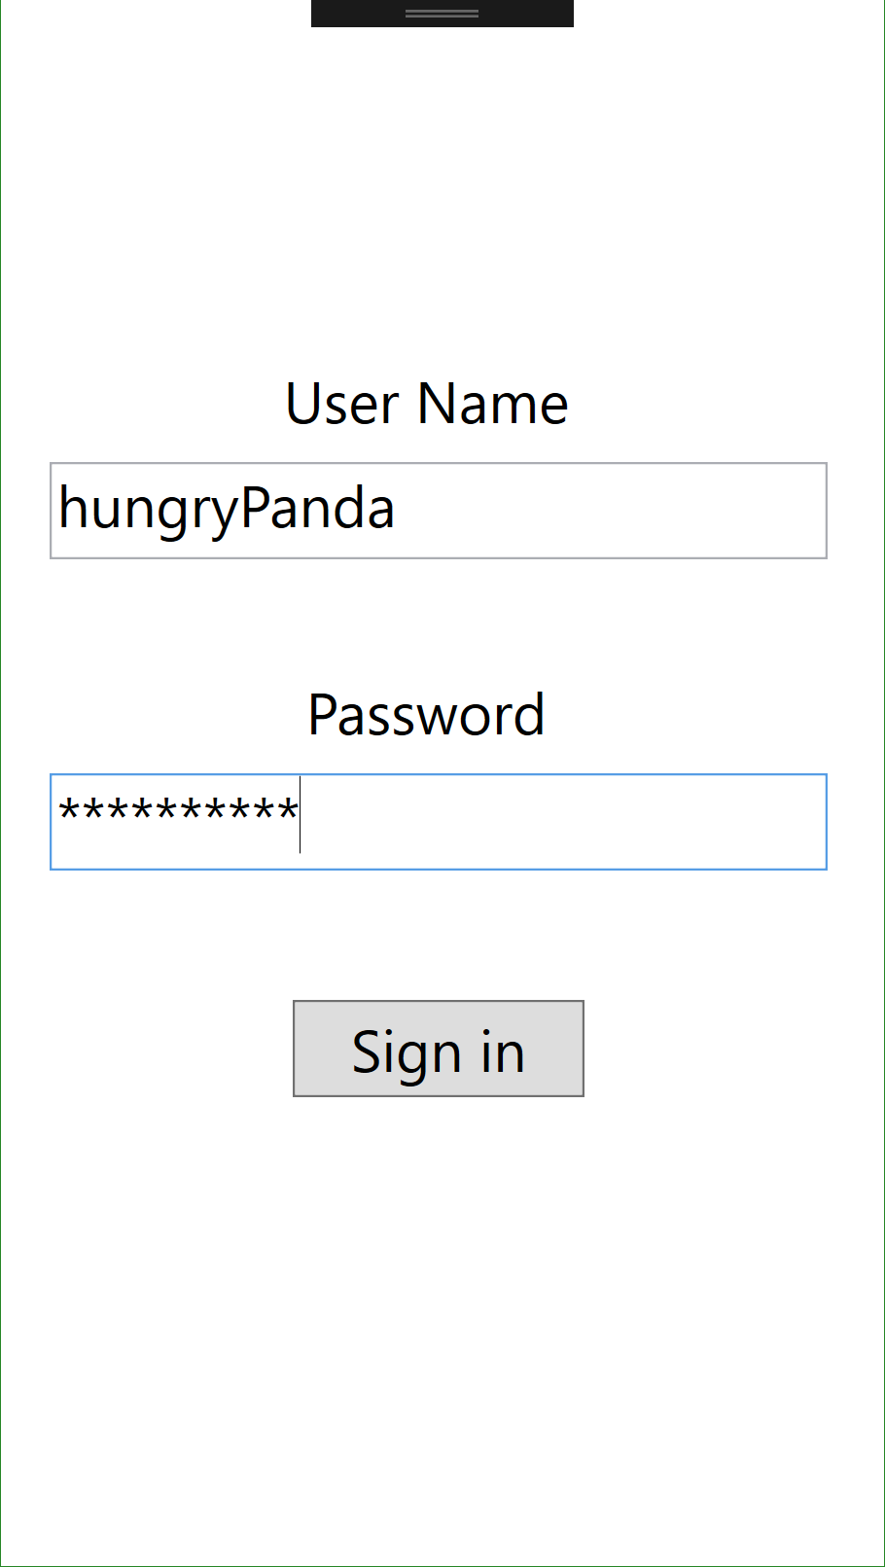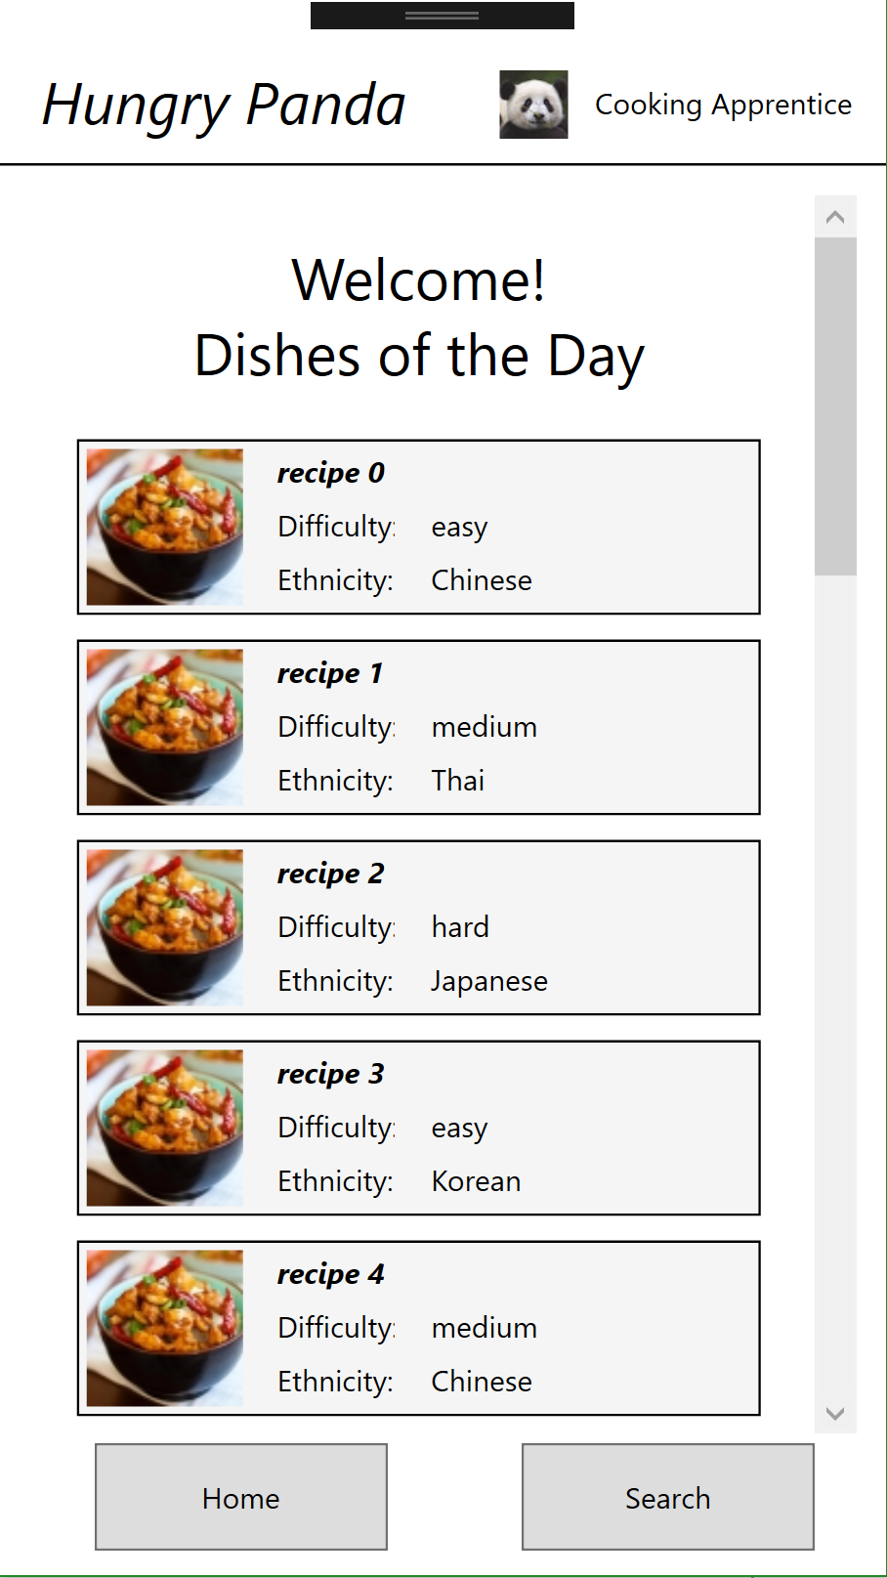

Loading screen Login screen Welcome page

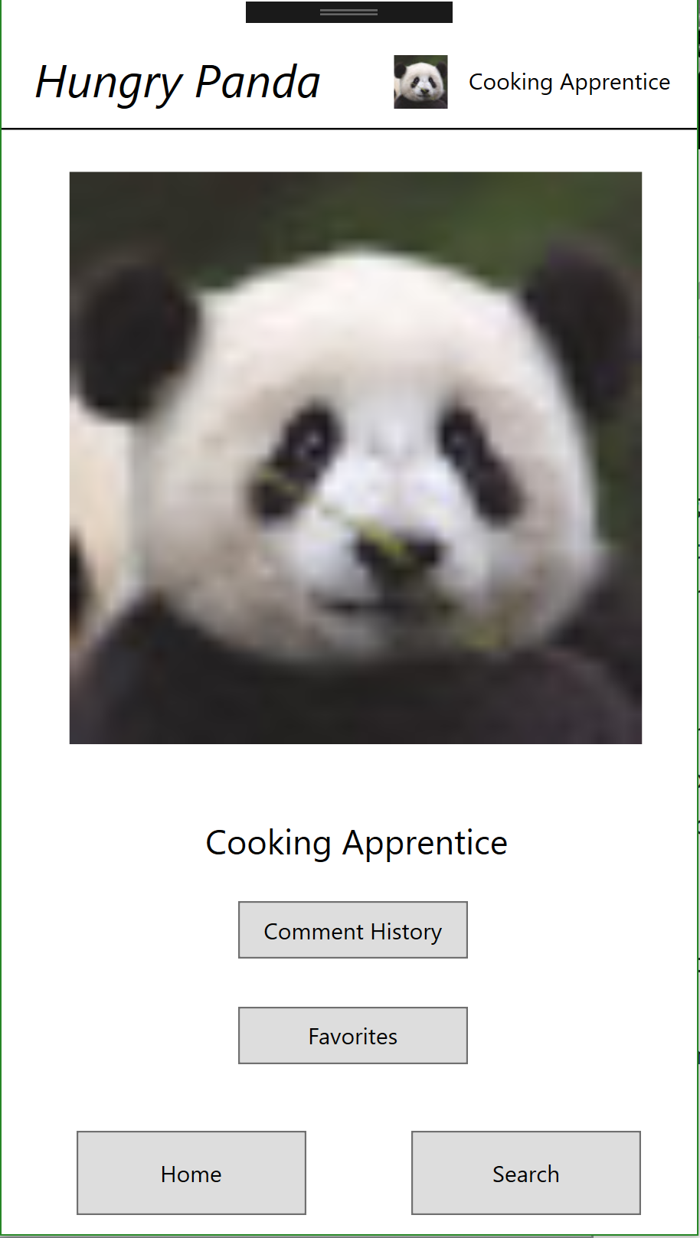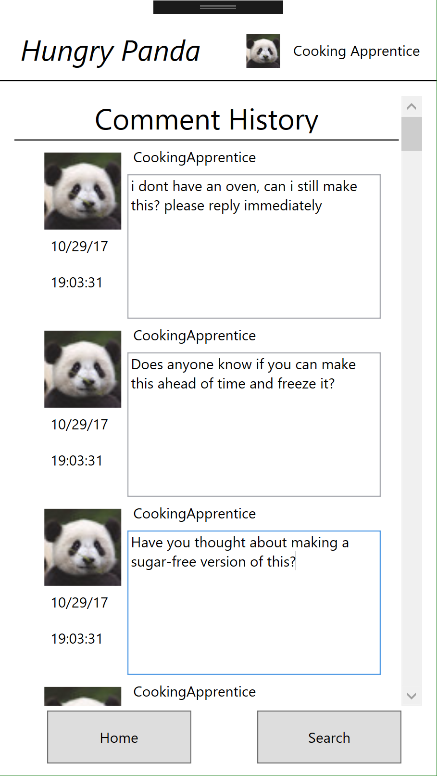

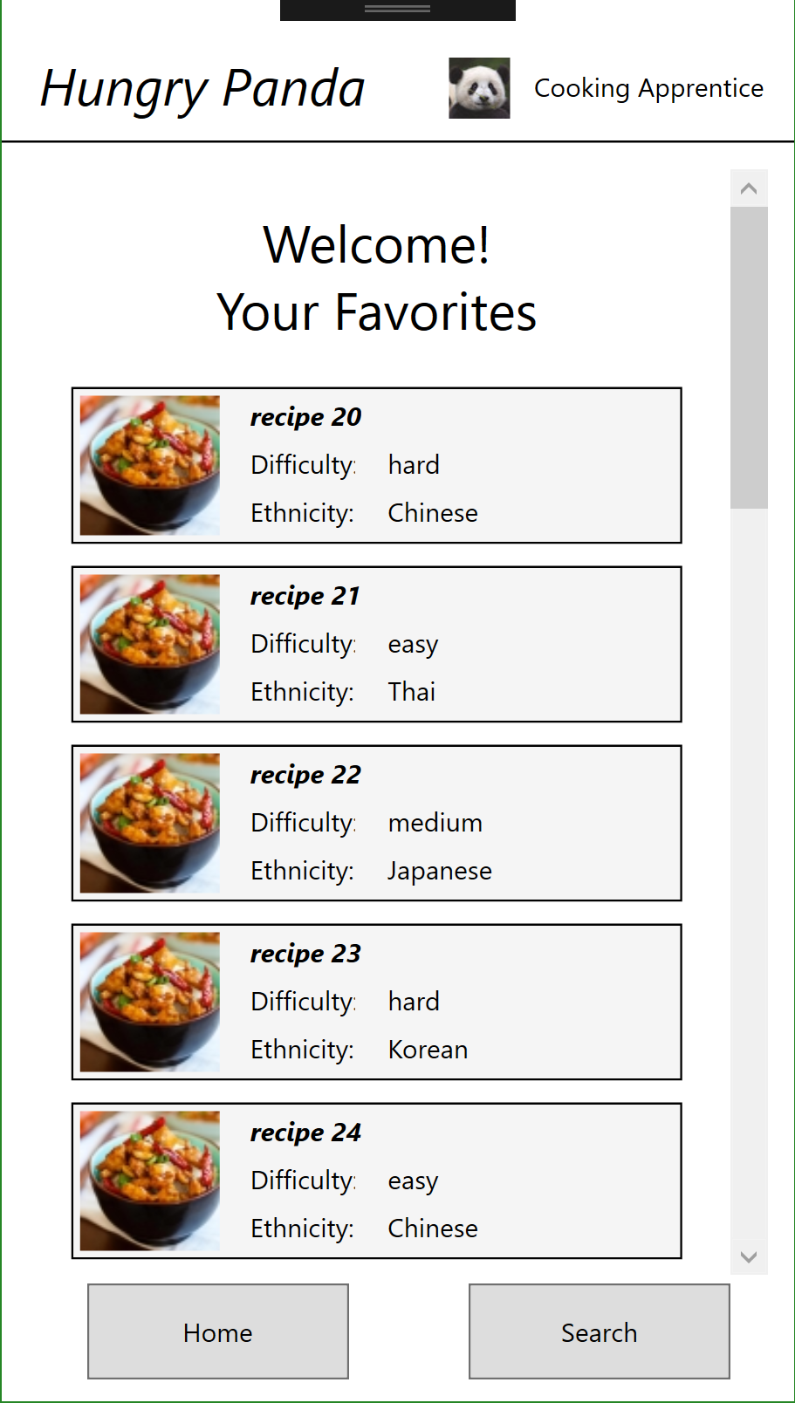

User information Comment history Favorite recipes

Search screen Recipe description Share screen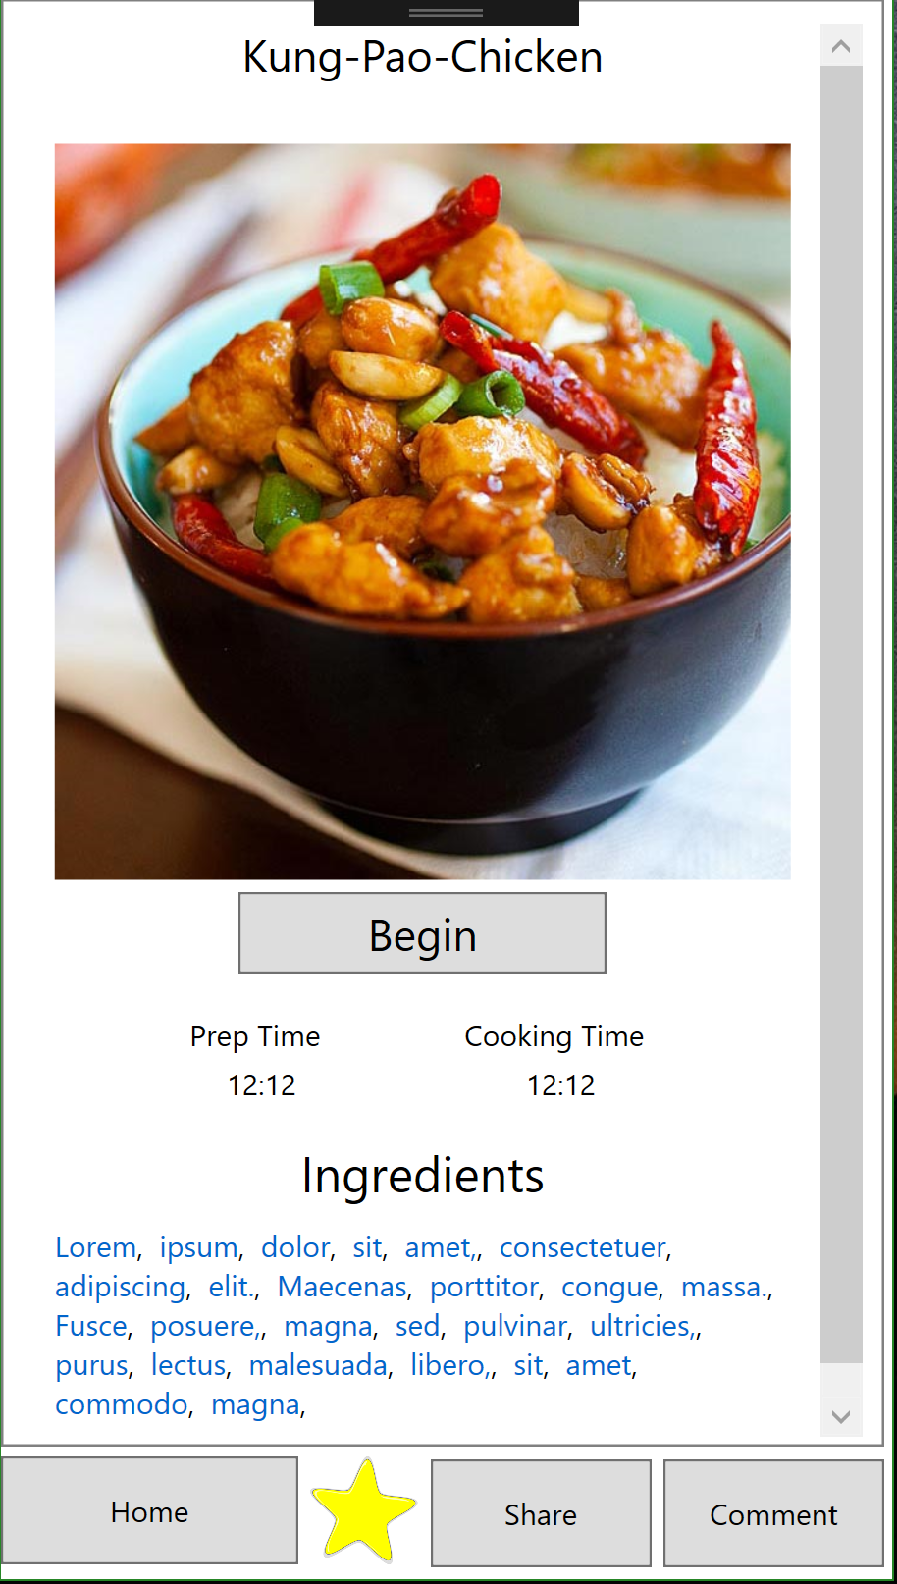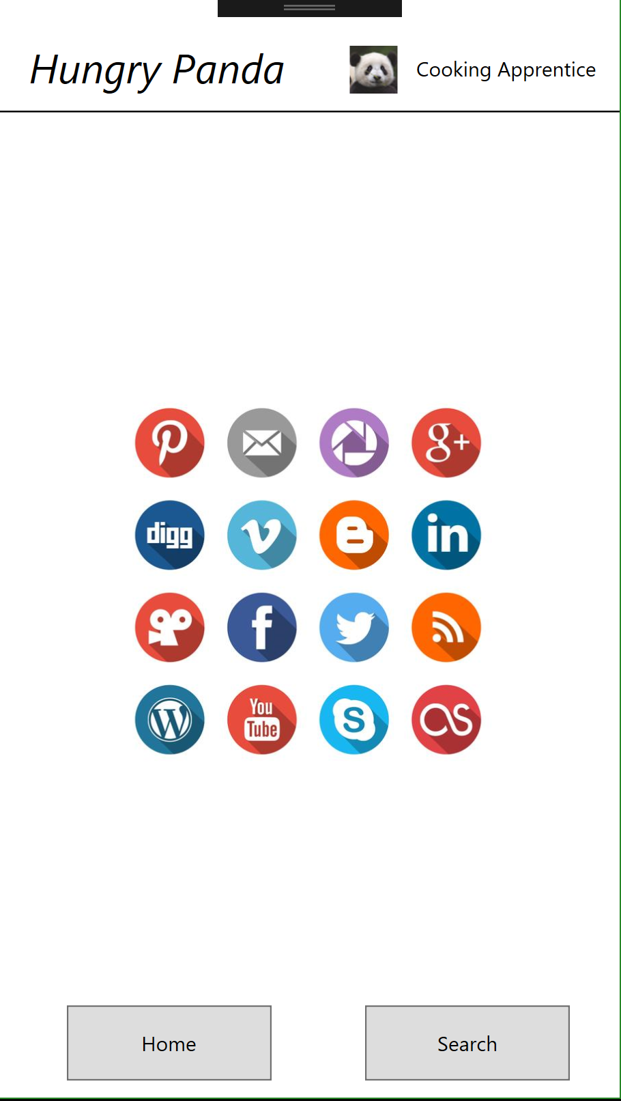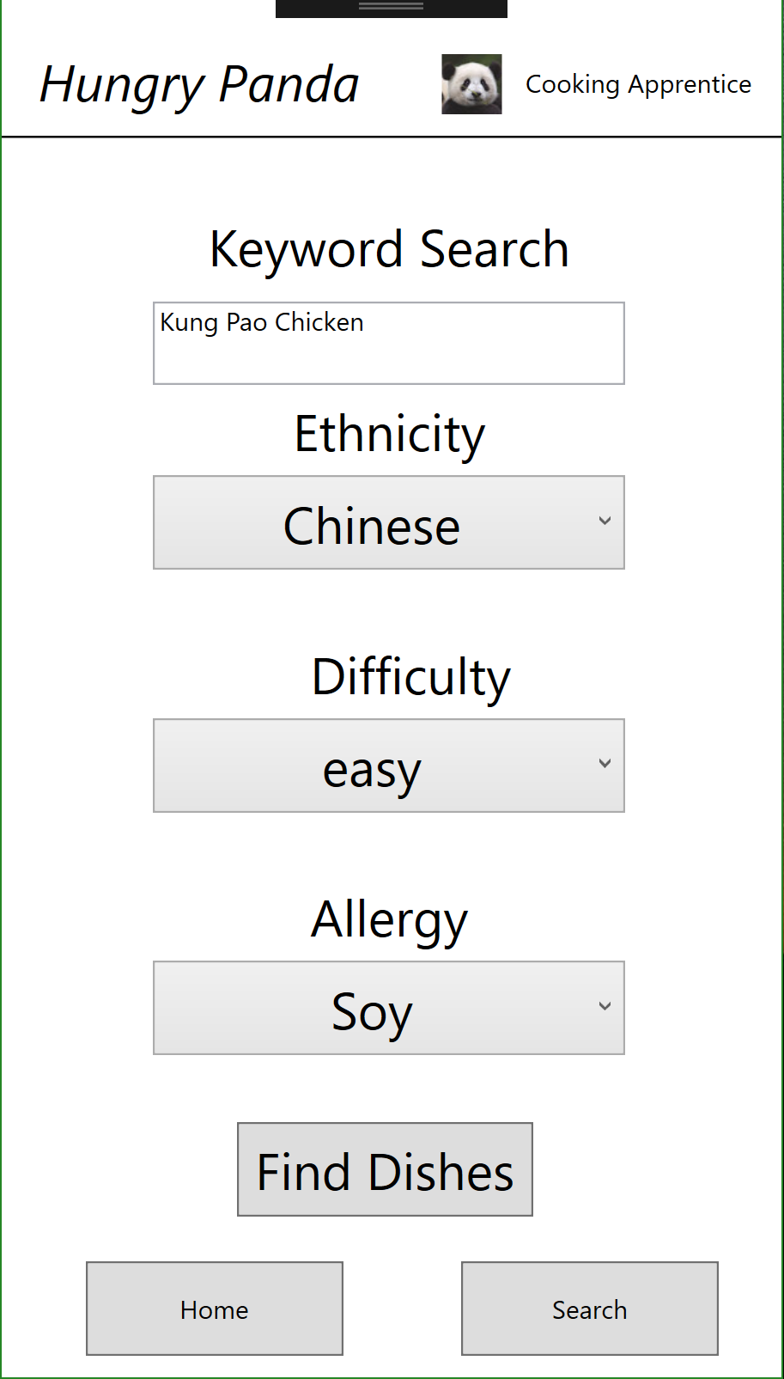

Ingredient description Review screen Step screen(1)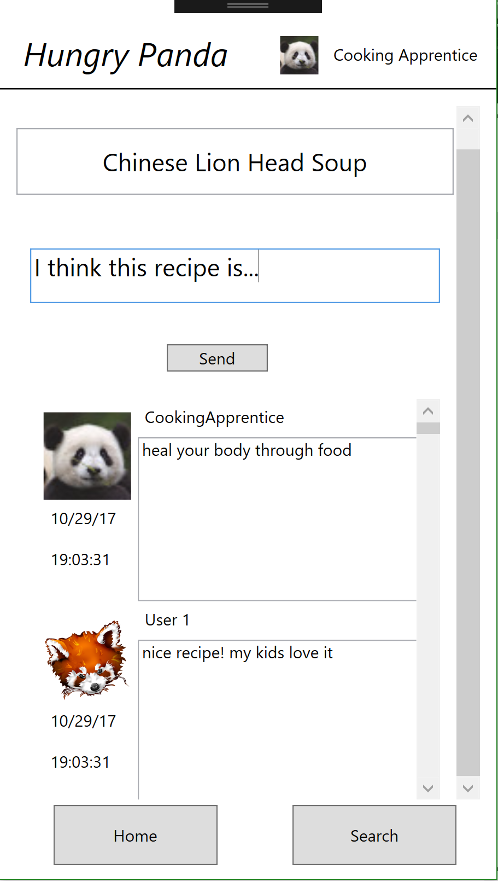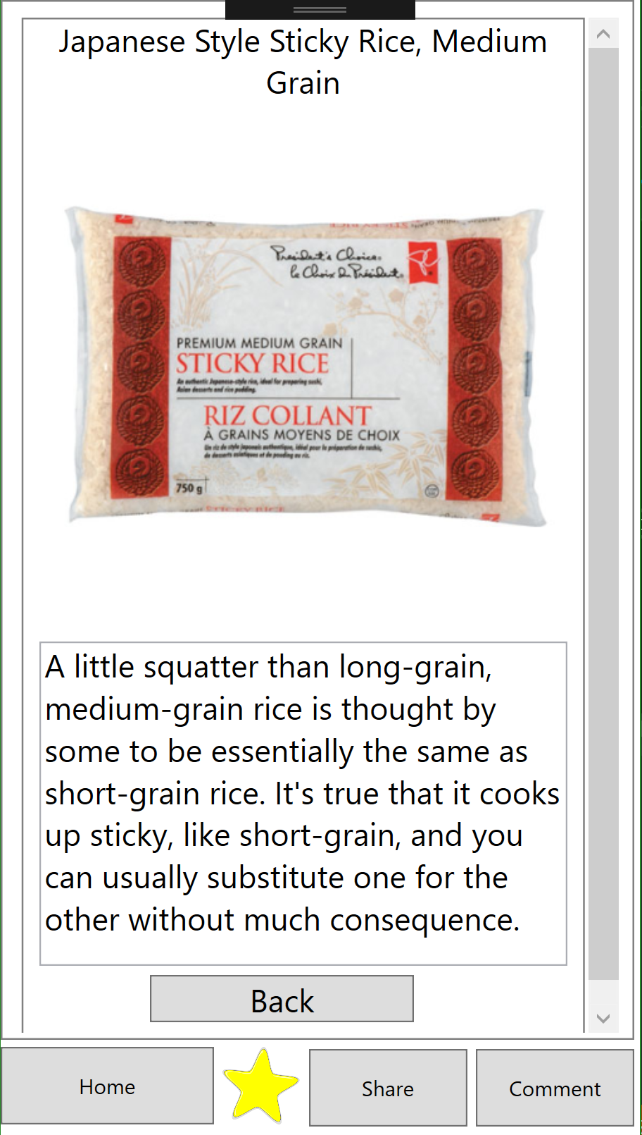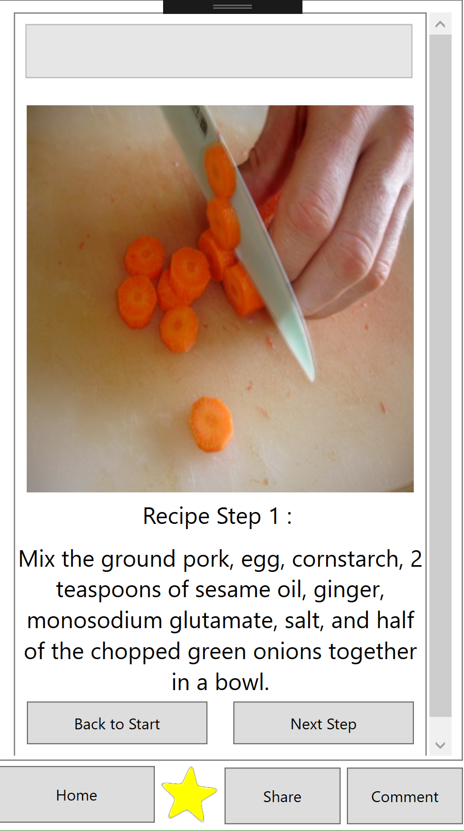

Step screen(2) Step screen(3) Step screen(4)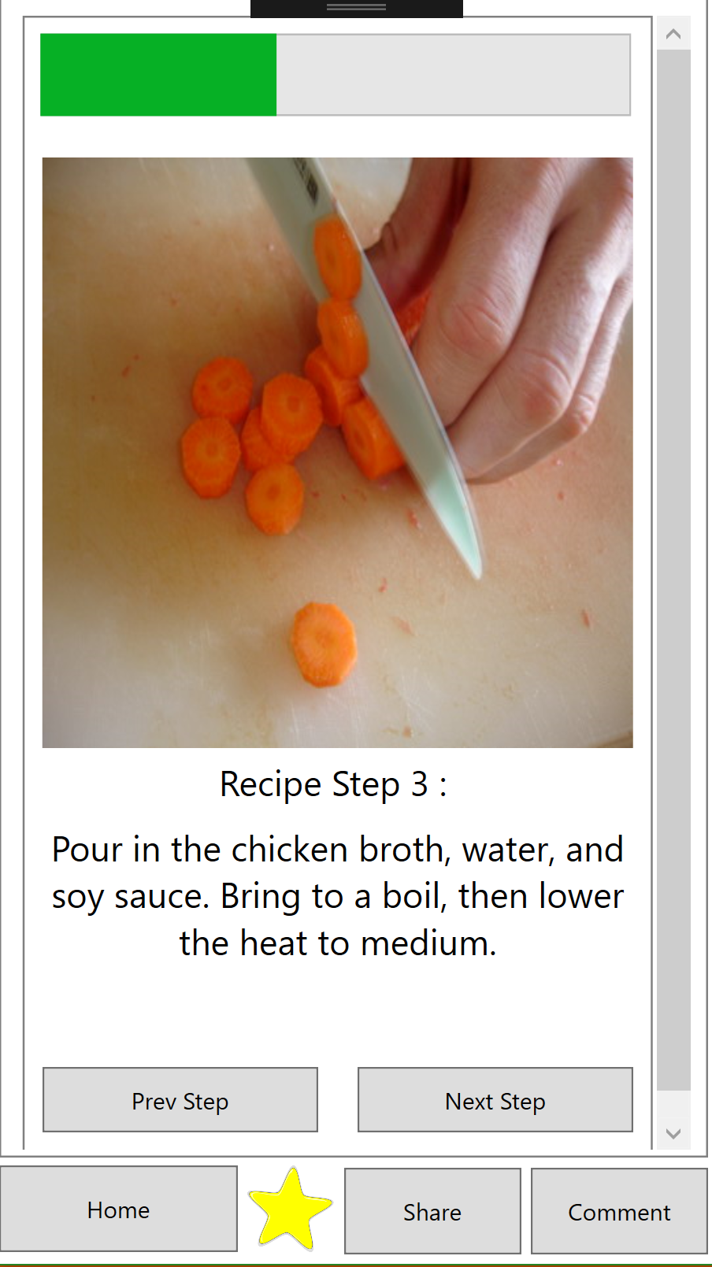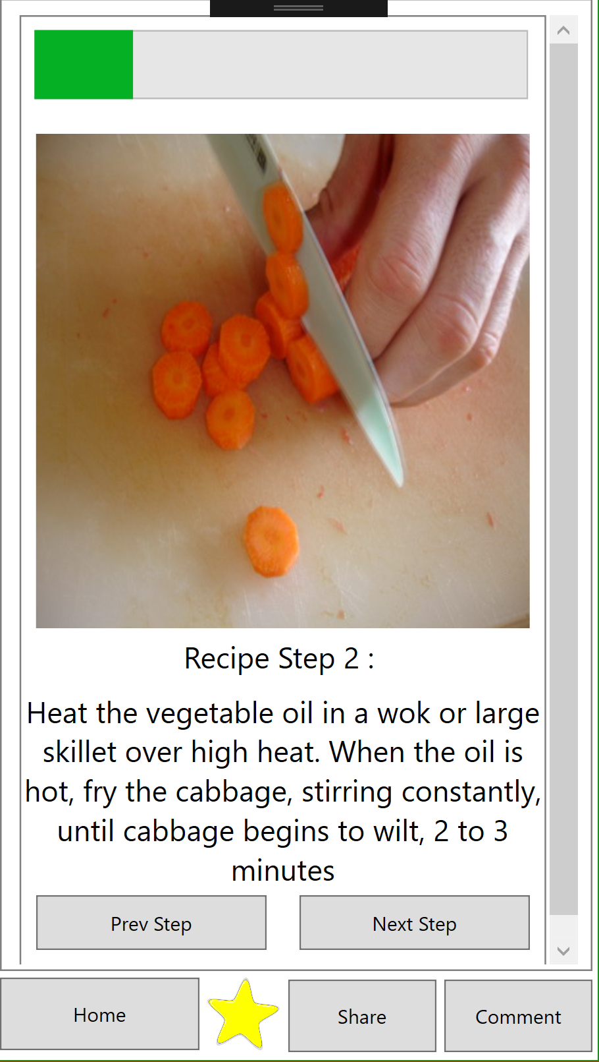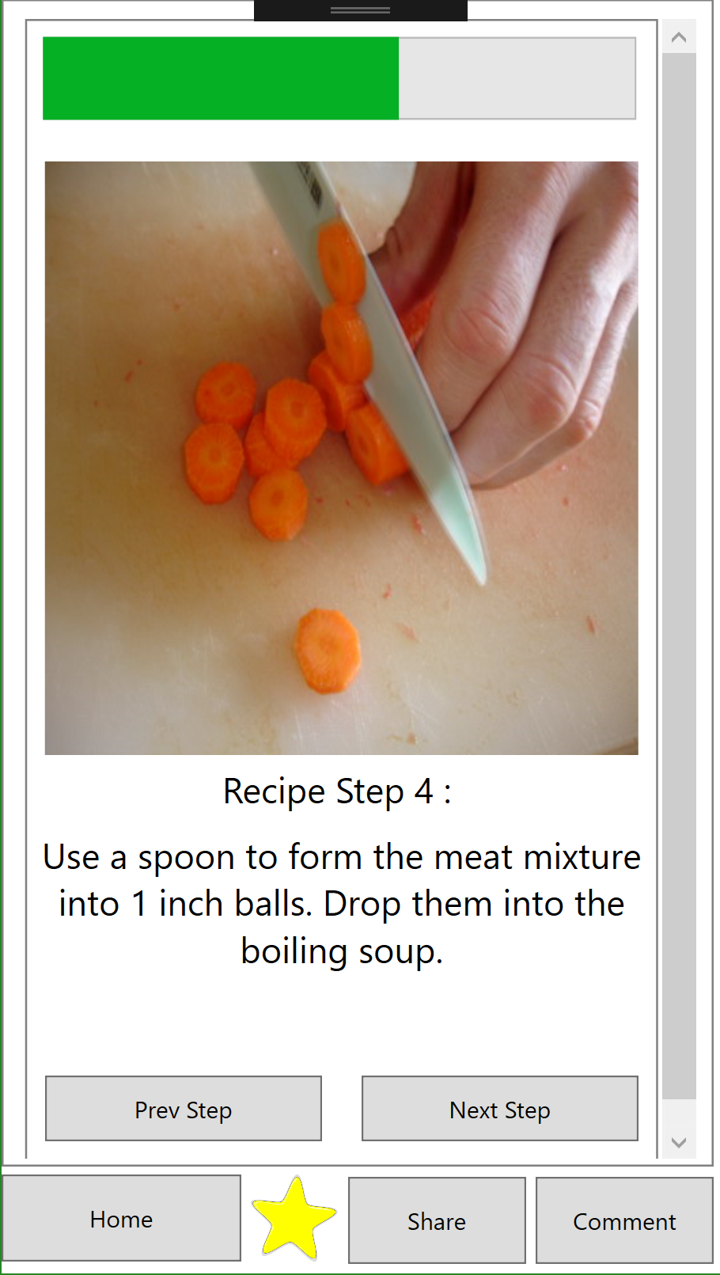

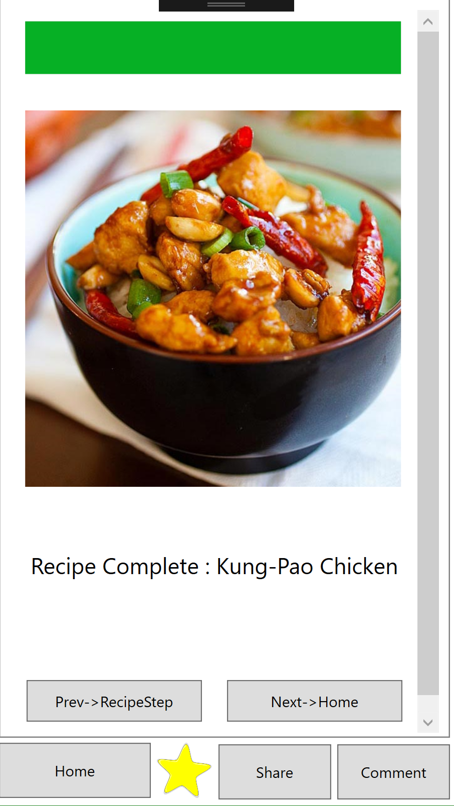

Step screen(5) Completion